ST PAUL’S UNIVERSITY

LIMURU CAMPUS

BCISLMR408022

UNIT NAME: SOFTWARE ENGINEERING II

UNIT CODE: BCS 3106

LEC: CECILIA ANGELA NAFUKA

DATE: 2/20224

TABLE OF CONTENT

1. Project Plan

1.1 Objective

1.2 Timeline

1.3 GANTT Chart

2. Software Requirements Specification

2.1 Introduction

2.2 Functional Requirements

2.3 Non-Functional Requirements

2.4 System Modeling

3. Requirements Traceability Matrix

4. Software Architecture and Design

4.1 Architectural Overview

4.2 Database Design

4.3 System Interfaces

5. Test Plan

5.1 Objective

5.2 Testing Strategy

5.3 Test Cases

6. GitHub Repository Link

**Project Plan**

**Title: Centralized Identification Platform Implementation Project**

**1.1 Objective:** Develop and implement a centralized identification platform for the Kenyan government to securely manage the personal data of its citizens.

**1.2 Timeline:**

Phase 1: Requirements Analysis and Planning (February - March 2024)

Phase 2: System Design and Architecture (April - May 2024)

Phase 3: Development and Testing (June - September 2024)

Phase 4: Deployment and Training (October - November 2024)

Phase 5: Maintenance and Support (Ongoing)

**1.3 GANTT Chart:**

|  |  |  |  |  |  |  |  |  |  |  |  |
| --- | --- | --- | --- | --- | --- | --- | --- | --- | --- | --- | --- |
| Task name | Feb2 | March2 | April2 | May2 | June2 | July2 | Aug2 | Sept2 | Oct2 | Nov2 | Dec2 |
| Planning |  |  |  |  |  |  |  |  |  |  |  |
| System design |  |  |  |  |  |  |  |  |  |  |  |
| Testing |  |  |  |  |  |  |  |  |  |  |  |
| Deployment & training |  |  |  |  |  |  |  |  |  |  |  |
| Maintenance |  |  |  |  |  |  |  |  |  |  |  |

**2. Software Requirements Specification (SRS) Document**

**2.1 Introduction:**

The purpose of this document is to outline the requirements for the development of a centralized identification platform for the Kenyan government.

**2.2 Functional Requirements:**

User Authentication

Data Collection (Fingerprints, eyes, faces, voices, DNA, location)

Data Storage and Management

Integration with Identity Cards

Integration with Education, Health, and Social Systems

**2.3 Non-Functional Requirements:**

Security Requirements

Performance Requirements

Usability Requirements

Compliance Requirements

**2.4 System Modeling:**

Use Case Diagram

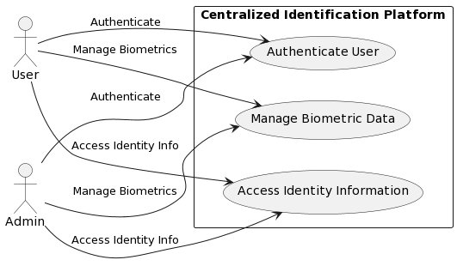

Class Diagram

Sequence Diagrams

**3. Requirements Traceability Matrix**

|  |  |  |  |
| --- | --- | --- | --- |
| Requirement ID | Description | Status | Test Case ID |
| 01 | User Authentication | Pending | 001 |
| 02 | Data collection | Pending | 002 |
| 03 | Data collection and Management | Pending | 003 |
| 04 | Integration with identity cards | Pending | 004 |
| 05 | Integration with education, health, and social systems | Pending | 005 |

**4. Software Architecture and Design Document**

**4.1 Architectural Overview:**

High-Level Design

Component Diagram

**4.2 Database Design:**

Entity-Relationship Diagram

System Interfaces:

External Interfaces

Internal Interfaces

**5. Test Plan**

**5.1 Objective**: Ensure the reliability and security of the centralized identification platform.

**5.2 Testing Strategy:**

Unit Testing

Integration Testing

System Testing

Acceptance Testing

Test Cases:

|  |  |  |  |  |  |  |
| --- | --- | --- | --- | --- | --- | --- |
| Test case ID | Description | Preconditions | Steps | Expected Results | Actual Results | Status |
| 001 | Test User Authentication Functionality | 1. The centralized identification platform is deployed and accessible.  2. Test user credentials are available. | 1.Navigate to the login page of the centralized identification platform.  2. Enter valid test user credentials (username and password).  3. Click on the "Login" button. | 1. The system should authenticate the user's credentials.  2. Upon successful authentication, the user should be redirected to the dashboard or home page of the platform.  3. If authentication fails (invalid credentials), an error message should be displayed, and the user should remain on the login page. | 1. The system successfully authenticates the user's credentials.  2. The user is redirected to the dashboard/home page of the platform.  3. No error message is displayed. | Pass |

Group GitHub Repository Link: [Provide link to the group GitHub repository]

Deliverable:

The project plan and SRS document provide a comprehensive overview of the project's scope, requirements, and timeline. The responsibility trace matrix ensures that each requirement is linked to corresponding test cases for validation. Additionally, the software architecture design document and test plan lay the groundwork for the development and testing phases of the project. The GitHub repository link allows for collaboration and version control within the group.